Middle School Science Fair Project

Fienberg-Fisher K-8 Center

Academic Year 2014-2015

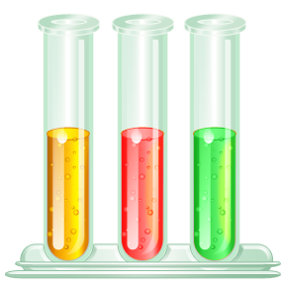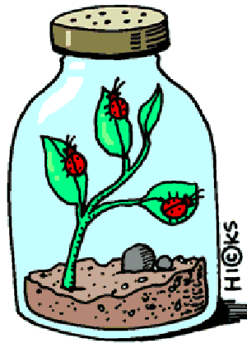

**SCIENTIST NAME:_______________________________**

Maria Zabala, Principal

Aisha Marrero, Assistant Principal

Mary Murphy, Assistant Principal

**Science Fair Project Assignments and Due Dates**

|  |  |  |  |
| --- | --- | --- | --- |
|  | Assignments | Due Dates | Graded in: |
| 1 | TOPIC/PROBLEM STATEMENT (pgs. 3-4) | P. 1, 3, & 5 – September 29th  P. 2, 4, & 6 – September 30th | Science |
| 2 | HYPOTHESIS (pg. 5) | P. 1, 3, & 5 – September 29th  P. 2, 4, & 6 – September 30th | Science |
| 3 | VARIABLES (pgs. 6-7)   * Manipulated (independent) * Responding (dependent) * Constants * Control | P. 1, 3, & 5 – September 29th  P. 2, 4, & 6 – September 30th | Science |
| 4 | MATERIALS (pg. 8) | P. 1, 3, & 5 – October 2nd  P. 2, 4, & 6 – October 3rd | Science |
| 5 | PROCEDURES (pg. 9) | P. 1, 3, & 5 – October 2nd  P. 2, 4, & 6 – October 3rd | Science |
| 6 | BLANK DATA TABLE w/o data (pg. 10) | P. 1, 3, & 5 – October 2nd  P. 2, 4, & 6 – October 3rd | Science |
| 7 | BACKGROUND INFORMATION WITH  BIBLIOGRAPHY (pg. 11) | October 15th | Language Arts and Science |
| 8 | DATA TABLES with data/and GRAPHS (pgs. 12-14) | November 5th | Math and Science |
| 9 | RESULTS/CONCLUSION (pg. 15) | November 5th | Math and Science |
| 10 | PRACTICAL APPLICATION (pg. 17) | November 5th | Science |
| 11 | ABSTRACT (pg. 18) | November 5th | Science |
| **12** | **FINAL PROJECT (TYPED) & CHECKLIST (pg. 19-20)** | **NOVEMBER 12th, 2014** | **Science** |

**SCIENCE FAIR PROJECT REPORT AND DISPLAY BOARD MUST BE TYPED**

<http://school.discoveryeducation.com/sciencefaircentral/>

<http://www.all-science-fair-projects.com/>

<http://www.ipl.org/div/projectguide/>

<http://www.homeworkspot.com/sciencefair/>

<http://www.sciencebuddies.org/>

Name_______________________________

**#1 - Topic/Problem is due on:   
P. 1, 3, & 5 – September 29th**

**P. 2, 4, & 6 – September 30th**

Date________________________________

Period______________

**#1 - Selecting a Topic and Identifying the Problem**

So, you’ve decided to enter the science fair, but you’re not sure where to begin. The first step, coming up with your project idea, could be the most important. Just remember, you’ll have a lot more fun (and probably learn more) if you start with a topic that interests you! Here are a few hints for coming up with a project idea:

1. **Think of a topic you’re interested in.** For example:

|  |  |  |
| --- | --- | --- |
| Animals | Plants | Space |
| Weather | Electricity | Rocks |

1. Of course, you could develop a hundred projects on any one of those topics. Now try to focus **on one aspect of one topic in particular**. For example:

* Animals: How can I best train my pet?
* Plants: How can plants best be protected from animals?
* Rocks: What do the different colors in the rocks mean?
* Electricity: How does electricity work?

1. That’s much better! **Now use this same idea, but be more specific.** What would you really like to figure out or show? Think of the most exact information you can discover and be very specific. For example:

* Animals: Does the length of an animal’s training session make a difference?
* Plants: Can a companion planting protect beans from beetles?
* Rocks: How do you detect minerals in rocks?
* Electricity: Can a worn-out battery do work?

1. Now, develop your problems statement (topic) by selecting a topic that can be answered only by experimenting. Then, write your topic as a question to be investigated. For example, “Which brand of paper towel is the most absorbent?”.
2. See table on next page for examples of good and poor problems statements. Is your problem statement good or poor?

|  |  |
| --- | --- |
| **Examples of Good and Poor Problem Statements** | |
| **Good** | **Why?** |
| 1. Do different colored mints dissolve at the same rate? | It required experimentation that you can do yourself. You must use the scientific method in completing this project. |
| 1. What surface do mealworms prefer? | It suggest the use of an experimental method. Asking a question is a good approach toward developing your topic |
| 1. Do all brands of paper towel absorb water at the same rate? | It is an investigation where only ONE variable is being manipulated. |
| **Poor** | **Why?** |
| 1. How volcanos erupt. | This topic will not allow experimentation without visiting real volcanos. Making a model that erupts is a demonstration not an experiment. |
| 1. Microscopes | This topic is too general. Telling how one works is NOT experimentation. |
| 1. Do different brands of paper towel soak up different temperatures of water at the same rate? | This topic needs to be narrowed down to ONE investigation. Only ONE variable should be manipulated in an investigation. |

**Problems Statement (Topic)**

**\*The problem statement should not be the same as project title.**

**Draft #1:**

What effect does __________________________________________________­­­___________

(test/independent variable)

have on _____________________________________________________________________.

(outcome/dependent variable)

Teacher Approval Signature:_____________________

**Draft #2 (rewrite with revisions)**

What effect does __________________________________________________­­­___________

(test/independent variable)

have on _____________________________________________________________________.

(outcome/dependent variable)

Teacher Approval Signature:_______________________

Name_______________________________

**#2 - Hypothesis is due on:   
P. 1, 3, & 5 – September 29th**

**P. 2, 4, & 6 – September 30th**

Date________________________________

Period______________

**#2 - Hypothesis**

**A hypothesis states what you think is going to happen when you investigate a question.**

1. Create a hypothesis statement for each of the situations below using the ***If and then format*** (If = the CAUSE) and (then = the EFFECT). A **hypothesis** is an “educated guess” or “prediction” that can be tested.

Example: “If Brawny, Viva, and Bounty paper towels are tested for their absorbency, then Bounty paper towels will be the most absorbent.”

**Draft #1**

The scientist believes that *if* ______________________________________________________

_____________________________________________________________________________

*then*_________________________________________________________________________

____________________________________________________________________________.

Teacher Approval Signature:_____________________

**Draft #2**

The scientist believes that *if* ______________________________________________________

_____________________________________________________________________________

*then*_________________________________________________________________________

____________________________________________________________________________.

Teacher Approval Signature:_____________________

**#3 -Variables is due on:   
P. 1, 3, & 5 – September 29th**

**P. 2, 4, & 6 – September 30th**

Name_______________________________

Date________________________________

Period______________

**#3 - Variables**

**Variables are all the factors that affect your investigation. There are three (3) types of variables.**

**Manipulated Variable (independent variable):** What you can change on purpose in an investigation.

Example: Brand of paper towels

**Responding Variable (dependent variable):** What changes by itself because you manipulated (changed) something in your investigation.

Example: Amount of water that is absorbed by each paper towel.

**Variables Held Constant:** Everything else in your investigation must be kept the same (the controlled variable).

Example: 1) Size of paper towel 2) Amount of water poured on each towel 3) Temperature of the water used 4) Container towels are placed in

1. The **constant** variables (all of the factors or conditions that will be kept identical for all of the trials) will be________________________________________________________

_______________________________________________________________________________________________________________________________________________.

_______________________________________________________________________.

1. The **independent (test) variable**, which will be changed and tested is________________

_______________________________________________________________________________________________________________________________________________

_______________________________________________________________________________________________________________________________________________.

1. The **dependent (outcome) variable**, which will be observed and measured, and will change as a result of the experiment, will ______________________________________

_______________________________________________________________________________________________________________________________________________________________________________________________________________________________________________________________________________________________________________________________________________________________________.

1. The **control**, which will receive NONE of the independent variable will be____________

_______________________________________________________________________________________________________________________________________________________________________________________________________________________________________________________________________________________________________________________________________________________________________________________________________________________________________________.

Name_______________________________

**#4 - Materials List is due on:   
P. 1, 3, & 5 – October 2nd**

**P. 2, 4, & 6 – October 3rd**

Date________________________________

Period______________

**#4 - Materials**

**List all the materials used in your investigation. Include specific details such as size, type, and quantity. Remember to use only metric units.** If you have more than 12 items add numbers.

|  |  |
| --- | --- |
| **Poor Example:** Paper Towels | **Good Example:** 3 - 15×15 cm. sheets of each paper towel: Brawny, Viva, and Bounty. |

**Draft #1**

1. 7.

2. 8.

3. 9.

4. 10.

5. 11.

6. 12.

Teacher Approval Signature:_____________________

**Draft #2**

1. 7.

2. 8.

3. 9.

4. 10.

5. 11.

6. 12.

Teacher Approval Signature:____________________

Name_______________________________

**#5 - Procedures are due on:   
P. 1, 3, & 5 – October 2nd**

**P. 2, 4, & 6 – October 3rd**

Date________________________________

Period______________

**#5 – Procedures**

**List your step-by-step directions like a recipe. Anyone who reads them should be able to replicate your investigation. Do not write what YOU did (avoid words such as “I” and “me”).**

|  |
| --- |
| Example: |
| 1. Cut 3 - 15×15 cm. Sq. from each brand of paper towels 2. Label each cut piece with brand names. 3. Pour 50ml. of 20̊ Celsius water into 20×20 cm. sq. pan. 4. Place 1 square of generic brand paper towel into the water and pan. 5. Leave for 30 seconds. 6. Remove paper towel. 7. Measure water remaining in pan and record 8. Dry the cake pan. 9. Repeat steps 4 through 8 for each brand of paper towel. 10. Repeat entire process twice more for each brand of paper towel. |

1.___________________________________________________________________________

2. ___________________________________________________________________________

3. ___________________________________________________________________________

4. ___________________________________________________________________________

5____________________________________________________________________________

6. ___________________________________________________________________________

7. ___________________________________________________________________________

8. ___________________________________________________________________________

9. ___________________________________________________________________________

10. __________________________________________________________________________

11. __________________________________________________________________________

Teacher Approval Signature:____________________

**#6 - Blank Data Table without data is** **due on:   
P. 1, 3, & 5 – October 2nd**

**P. 2, 4, & 6 – October 3rd**

Name_______________________________

Date________________________________

Period______________

**#6 - Data Table**

**Refers to information gathered during your investigation (notes, table, charts, or graphs). The data that you gather during the course of your investigation needs to be quantifiable (measureable).**

Title (a short description of the data being displayed)

Title:_____________________________________

|  |  |  |  |  |
| --- | --- | --- | --- | --- |
| Independent  Variable | Dependent Variable  Trials | | | |
| 1 | 2 | 3 | Mean |
|  |  |  |  |  |
|  |  |  |  |  |
| Control |  |  |  |  |

Teacher Approval Signature:____________________

Title:_____________________________________

|  |  |  |  |  |
| --- | --- | --- | --- | --- |
| Independent  Variable | Dependent Variable  Trials | | | |
| 1 | 2 | 3 | Mean |
|  |  |  |  |  |
|  |  |  |  |  |
| Control |  |  |  |  |

Teacher Approval Signature:___________________

Name_______________________________

**#7 - Background Information with Bibliography is due on:   
P. 1-6 October 15th**

Date________________________________

Period______________

**#7 -Background Information Guidelines**

* Must be **3-5 typed pages**.
* Must be double spaced.
* Font must be 12 pt (Arial or Times New Roman).
* Must have 1 inch margins all around.
* Must include bibliography (use [www.easybib.com](http://www.easybib.com)).
* Must have at least 3 different resources (book, journal, encyclopedias, and/or internet).
* Must follow correct grammar and punctuation.

**PLAGIARISM**: to use and pass off (the ideas or writings of another) as one’s own. Do not do this, it is illegal and you will receive a zero on your project for doing it.

**Bibliography**

**Make a list of all books, magazines, internet articles, interviews, or other sources that were use.**

1._____________________________________________________________________________________________________________________________________________________________________________________________________________________________________

2._____________________________________________________________________________________________________________________________________________________________________________________________________________________________________

3._____________________________________________________________________________________________________________________________________________________________________________________________________________________________________

4.________________________________________________________________________________________________________________________________________________________ 5.___________________________________________________________________________ _____________________________________________________________________________

**#8 –Data Tables with data and graphs is due on:   
P. 1-6 - November 5th**

**Constructing Graphs**

Graphs are a useful tool in science. The visual characteristics of a graph make trends in data easy to see. One of the most valuable uses for graphs is to “predict” data that is not measured on the graph.

|  |  |  |
| --- | --- | --- |
| Step | What To Do | How To Do It |
| 1 | Identify the variables | 1. Independent Variable- (controlled by the experimenter)  * Goes on the X-axis (horizontal) * Should be on the left side of a data table  1. Dependent Variable- (changes because of the independent variable)  * Goes on the Y-axis (vertical) * Should be on the right side of the data table |
| 2 | Determine the variable range | 1. Subtract the lowest data value from the highest data value 2. Do each variable separately |
| 3 | Determine the scale of the graph | 1. Determine a scale (the numerical value for each square)that best fits the rage of each variable 2. Spread the graph to use MOST of the available space |
| 4 | Number and label each axis | This tells what data the lines on your graph represent. |
| 5 | Plot the data points | 1. Plot each data value on the graph with a dot 2. You can put the data number by the dot, if it does not clutter your graph |
| 6 | Draw the graph | 1. Draw a curve or a line that best fits the data points 2. Most graphs of experimental data are not drawn as “connect-the-dots” |
| 7 | Title the graph | 1. Your title should clearly tell what the graph is about 2. The title of your graph is often the same as the title of your table 3. If your graph has more than one set of data, provide a “key” to identify the different lines. |

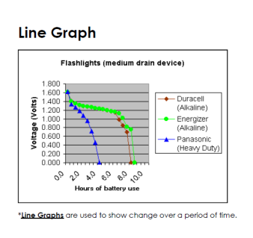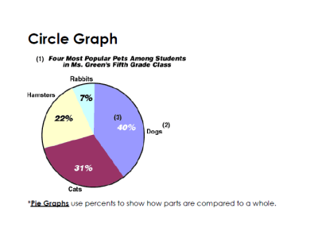

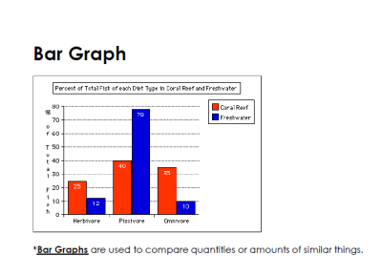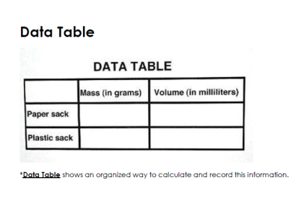

**#8 - Data Tables with data and graphs is due on:   
November 5th**

Name_______________________________

Date________________________________

Period______________

GRAPH

|  |  |  |  |  |  |  |  |  |  |  |  |  |  |  |  |  |  |  |  |  |  |  |  |  |  |  |
| --- | --- | --- | --- | --- | --- | --- | --- | --- | --- | --- | --- | --- | --- | --- | --- | --- | --- | --- | --- | --- | --- | --- | --- | --- | --- | --- |
|  |  |  |  |  |  |  |  |  |  |  |  |  |  |  |  |  |  |  |  |  |  |  |  |  |  |  |
|  |  |  |  |  |  |  |  |  |  |  |  |  |  |  |  |  |  |  |  |  |  |  |  |  |  |  |
|  |  |  |  |  |  |  |  |  |  |  |  |  |  |  |  |  |  |  |  |  |  |  |  |  |  |  |
|  |  |  |  |  |  |  |  |  |  |  |  |  |  |  |  |  |  |  |  |  |  |  |  |  |  |  |
|  |  |  |  |  |  |  |  |  |  |  |  |  |  |  |  |  |  |  |  |  |  |  |  |  |  |  |
|  |  |  |  |  |  |  |  |  |  |  |  |  |  |  |  |  |  |  |  |  |  |  |  |  |  |  |
|  |  |  |  |  |  |  |  |  |  |  |  |  |  |  |  |  |  |  |  |  |  |  |  |  |  |  |
|  |  |  |  |  |  |  |  |  |  |  |  |  |  |  |  |  |  |  |  |  |  |  |  |  |  |  |
|  |  |  |  |  |  |  |  |  |  |  |  |  |  |  |  |  |  |  |  |  |  |  |  |  |  |  |
|  |  |  |  |  |  |  |  |  |  |  |  |  |  |  |  |  |  |  |  |  |  |  |  |  |  |  |
|  |  |  |  |  |  |  |  |  |  |  |  |  |  |  |  |  |  |  |  |  |  |  |  |  |  |  |
|  |  |  |  |  |  |  |  |  |  |  |  |  |  |  |  |  |  |  |  |  |  |  |  |  |  |  |
|  |  |  |  |  |  |  |  |  |  |  |  |  |  |  |  |  |  |  |  |  |  |  |  |  |  |  |
|  |  |  |  |  |  |  |  |  |  |  |  |  |  |  |  |  |  |  |  |  |  |  |  |  |  |  |
|  |  |  |  |  |  |  |  |  |  |  |  |  |  |  |  |  |  |  |  |  |  |  |  |  |  |  |
|  |  |  |  |  |  |  |  |  |  |  |  |  |  |  |  |  |  |  |  |  |  |  |  |  |  |  |
|  |  |  |  |  |  |  |  |  |  |  |  |  |  |  |  |  |  |  |  |  |  |  |  |  |  |  |
|  |  |  |  |  |  |  |  |  |  |  |  |  |  |  |  |  |  |  |  |  |  |  |  |  |  |  |
|  |  |  |  |  |  |  |  |  |  |  |  |  |  |  |  |  |  |  |  |  |  |  |  |  |  |  |
|  |  |  |  |  |  |  |  |  |  |  |  |  |  |  |  |  |  |  |  |  |  |  |  |  |  |  |
|  |  |  |  |  |  |  |  |  |  |  |  |  |  |  |  |  |  |  |  |  |  |  |  |  |  |  |
|  |  |  |  |  |  |  |  |  |  |  |  |  |  |  |  |  |  |  |  |  |  |  |  |  |  |  |
|  |  |  |  |  |  |  |  |  |  |  |  |  |  |  |  |  |  |  |  |  |  |  |  |  |  |  |
|  |  |  |  |  |  |  |  |  |  |  |  |  |  |  |  |  |  |  |  |  |  |  |  |  |  |  |
|  |  |  |  |  |  |  |  |  |  |  |  |  |  |  |  |  |  |  |  |  |  |  |  |  |  |  |
|  |  |  |  |  |  |  |  |  |  |  |  |  |  |  |  |  |  |  |  |  |  |  |  |  |  |  |
|  |  |  |  |  |  |  |  |  |  |  |  |  |  |  |  |  |  |  |  |  |  |  |  |  |  |  |
|  |  |  |  |  |  |  |  |  |  |  |  |  |  |  |  |  |  |  |  |  |  |  |  |  |  |  |
|  |  |  |  |  |  |  |  |  |  |  |  |  |  |  |  |  |  |  |  |  |  |  |  |  |  |  |
|  |  |  |  |  |  |  |  |  |  |  |  |  |  |  |  |  |  |  |  |  |  |  |  |  |  |  |
|  |  |  |  |  |  |  |  |  |  |  |  |  |  |  |  |  |  |  |  |  |  |  |  |  |  |  |
|  |  |  |  |  |  |  |  |  |  |  |  |  |  |  |  |  |  |  |  |  |  |  |  |  |  |  |

Name______________________________

**#9 - Results and Conclusion are due on:   
P. 1-6 – November 6th**

Date________________________________

Period______________

**#9 - Results**

**Write the results of the experiment based on the information you have observed.**

Example: The results of the experiment did support the hypothesis. A sheet of Viva paper towel absorbed an average of 50ml of water. A sheet of Suave paper towel absorbed an average of 36ml of water.

The results of the experiment ________________________________ support the

(did or did not)

hypothesis.

**#9 Conclusion**

Remember the conclusion must be written in the past tense because you have already finished the experimentation. Be sure to examine all your data (graphs, charts, tables). The following questions need to be answered in paragraph format:

1. What was investigated?
2. Was the hypothesis supported or not supported by the data?
3. What were the major findings?
4. How did your findings compare with other researchers?
5. What possible explanations can you offer for any errors in your findings? Can you identify any bias in your investigation?
6. What recommendations do you have for further study and improving the experiment?
7. What are some possible applications of this experiment?

_____________________________________________________________________________

_____________________________________________________________________________

_____________________________________________________________________________

_____________________________________________________________________________

_____________________________________________________________________________

_____________________________________________________________________________

_____________________________________________________________________________

_____________________________________________________________________________

_____________________________________________________________________________

_____________________________________________________________________________

_____________________________________________________________________________

_____________________________________________________________________________

_____________________________________________________________________________

_____________________________________________________________________________

_____________________________________________________________________________

_____________________________________________________________________________

_____________________________________________________________________________

_____________________________________________________________________________

_____________________________________________________________________________

_____________________________________________________________________________

_____________________________________________________________________________

_____________________________________________________________________________

_____________________________________________________________________________

_____________________________________________________________________________

_____________________________________________________________________________

_____________________________________________________________________________

_____________________________________________________________________________

_____________________________________________________________________________

_____________________________________________________________________________

_____________________________________________________________________________

_____________________________________________________________________________

_____________________________________________________________________________

_____________________________________________________________________________

_____________________________________________________________________________

Name_______________________________Date________________________________Period______________

**#10 – Practical Application is due on:   
P. 1-6 – November 5th**

**Practical Application**

**An application is how the project relates to real life.**

|  |
| --- |
| Example: |
| Having tested three brands of paper towels. Brawny, Viva, and Bounty for the best absorbency, it is now known from this experiment that from these three branded paper towels, Bounty paper towel has the most absorbency. With this information, consumers may now be able to make a more scientific decision when choosing the brand of paper towel. If the consumer wishes to purchase a paper towel product with more absorbency then Bounty is the paper towel to purchase. However, not always does a consumer want the most absorbent paper towel and despite knowing this information, the consumer will not purchase the Bounty paper towel but rather another brand, perhaps Viva which absorbed the least from the three brands tested. |

How can your project be applied in the real world?

_____________________________________________________________________________

_____________________________________________________________________________

_____________________________________________________________________________

_____________________________________________________________________________

_____________________________________________________________________________

_____________________________________________________________________________

_____________________________________________________________________________

_____________________________________________________________________________

_____________________________________________________________________________

_____________________________________________________________________________

_____________________________________________________________________________

_____________________________________________________________________________

_____________________________________________________________________________

_____________________________________________________________________________

_____________________________________________________________________________

Name__________________________

**#11 – Abstract is due on:   
P. 1-6 – November 5th**

Date___________________________

Period__________

**Abstract**

**A summary of the entire project. It is written in three (3) paragraphs.**

|  |
| --- |
| ¶ (Paragraph) 1 – Purpose of the experiment and the Hypothesis  ¶ (Paragraph) 2 – Procedures  ¶ (Paragraph) 3 – Results and the Conclusion |

The problem was__________________________________________________________

_____________________________________________________________________________

____________________________________________________________________________.

It was hypothesized that if________________________________________________________

________________________________, then________________________________________

____________________________________________________________________________.

The procedure followed was_________________________________________________

___________________________________________________________________________________________________________________________________________________________________________________________________________________________________________________________________________________________________________________.

I concluded that____________________________________________________________

____________________________________________________________________________________________________________________________________________________

The results of the experiment________________________________supported the hypothesis.

**#12 – Checklist and Completed Project Report and Display Board typed is due on:  
P. 1-6 – November 12th**

**Science Fair Report Checklist**

This report is placed at the base of your project board.

_______ Cover page and Heading

_______ Table of contents: list form with page numbers.

_______ Scientific title: The effect of _____________________ on ___________________.

_______ Problem: Question form---- What is the effect of ___(Indep. Variable)_________ on

_____(Dep. Variable)______________________?

_______ Hypothesis: It is hypothesized that if __________________________________ then

__________________________­­­_________________________________.

_______ Variables: Independent, Dependent, Control, Constants

_______ Materials: be very specific and use the metric system

_______ Procedures: be very specific, include taking pictures, include trials.

_______ Data: Table (needs title, units, include three-five trials, mean)

_______ Data: Graph (needs title, axis labeled, units, ----either 4 graphs---one for each trial

and one for the mean or 1 graph----that contains all of the trials and mean)

_______ Results: Discuss the findings, what numbers did you obtain? Discuss the data

obtained for the mean.

_______ Conclusion: follow the format given to you.

_______ Practical Application: what real application does your project have in real life?

Who would be interested in knowing about your findings, and why?

_______ Abstract: follow the format given to you.

_______ Background Information Paper: 3-5 pages

_______ Bibliography: minimum 3 references

_______ Science Fair Packet at your LOG BOOK (rough draft)

Sample Science Fair Project Board Set-up

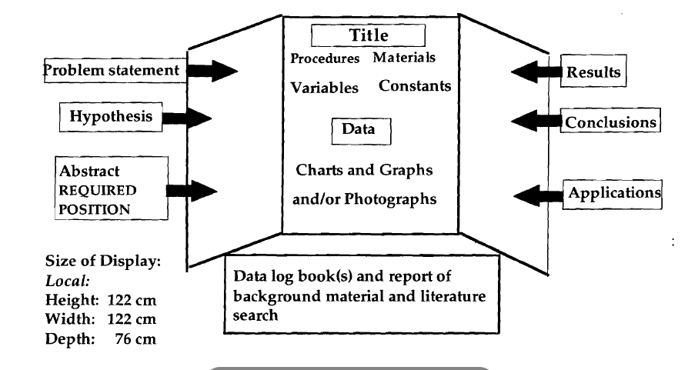**Helpful Hints:**

* **Take photographs**: Many projects involve elements that may not be safely exhibited at the fair, but are an important part of the project. Photographs should be taken of important parts/phases of the experiment to use in the display. Please do NOT include any photos of people’s faces.
* **Be organized**: Make sure the display is logically presented and easy to read. A glance should permit anyone (particularly the judges) to locate quickly the title, experiments, results, and conclusions.
* **Eye-catching**: Make the display stand out. Use neat, colorful headings, charts, and graphs to present the project. Pay special attention to labeling, graphs, charts, diagrams, and tables. Each item must have a descriptive title. Anyone should be able to understand the visuals without further explanation.

**Oral Presentation**

**If selected for your grade level to enter Fienberg-Fisher K-8 Science Fair in the Media Center.**

1. Introduce yourself.
2. Give the title of your project and its purpose.
3. Briefly explain why you became interested in this project.
4. Explain you procedures, relate the number of trials, and show your results using tables, charts, or graphs.
5. Explain your conclusions (what you’ve proven). If there were any errors or problems, explain how this may have affected the experiment’s outcome.
6. Tell what you might do differently next time.
7. Explain how your project can help others.

**\*\*Suggestions\*\***

1. Smile and be polite
2. Stand straight and still
3. Keep eye contact with your audience.
4. Project your voice so that everyone can hear you.
5. Stand to the side of the display board.
6. Show enthusiasm.

C:\Users\291127\AppData\Local\Microsoft\Windows\Temporary Internet Files\Content.IE5\C9EN5ZNC\MC900060329[1].wmfGood Job Scientist!